CCPi Quantification Codes User Guide

|  |  |  |
| --- | --- | --- |
| 01/02/2017 | Mr. Srikanth Nagella | First version of userguide. |
| 2/2/2017  7/2/2017 | Erica Yang | Added all the code description from CCPi SourceForge, and comments |

Contents

Introduction 1

Nexus Reader 2

Algorithms 2

Accessible Volume 2

3D Quantification 2

Particle Tracking 2

Nexus Reader 3

Installation 3

Avizo Plugin 3

ImageJ Plugin 3

Paraview Plugin 3

Reconstruction 4

Comments 4

Avizo Plugin 4

Documentation 5

# Introduction

There are few quantification algorithms that are written as plugins to the three data analysis application. The three applications are Avizo, Paraview and ImageJ. This document describes the algorithms in general and then describes how to install and use the quantification algorithms in these data analysis applications.

# Nexus Reader

1. Only way to load nexus/diamond data into Avizo
2. Subsampling of data

# Algorithms

There are currently four quantification algorithms implemented. Below is the brief description about the algorithms.

# Accessible Volume

This algorithm is written by Sheng Yue at MXIF. The algorithm takes in a binary 3D image (Usually a scaffold images) and calculates the accessible volume for a range of sphere sizes. The algorithm also takes in input mask which defines the boundary of the volume from where the accessibility is measured. The algorithm is described in Sheng Yue PhD thesis. (<http://dx.doi.org/10.1016/j.jmatprotec.2014.05.006>)

# 3D Quantification

This algorithm takes in a labelled image and calculates several characteristics for each label. Below are some of the characteristics

* Volume by voxel counts
* Equivalent sphere diameter by voxel counts
* Bounding box diagonal
* Principal Component Analysis (PCA)
* Ellipsoid fitting by PCA
* Equivalent circle diameter by PCA
* Isosurface by marching cude.
* Surface area
* Surface Volume
* Equivalent sphere diameter from surface volume
* Sphercity
* Normalised surface area to volume ratio (Radius*Sa/Vol)

The details of this algorithm are given in Evaluation of 3D bioactive glass scaffolds dissolution in a perfusion flow system with X-ray microtomography. Yue S, Lee PD, Poologasundarampillai G, Jones JR. DOI: [10.1016/j.actbio.2011.02.009](https://dx.doi.org/10.1016/j.actbio.2011.02.009)

# ****Particle Tracking****

This algorithm calculates tracks of particles in 3D images. It requires labelled images to work correctly but it doesn’t require that the labels be consistent across all images. The location of each particle is calculated as the mean position of voxels with a given label. This will be improved later so the algorithm can locate particles for itself (removing the requirement for labelled images).

This algorithm is originally written by Dr. Peter Lee.

# Nexus Reader

Some of the applications are missing a reader for DLS data which is in nexus format. This module bridges the gap so that the nexus data can be read into applications like Avizo, ImageJ and Paraview. The module also provides option to select a dataset and subset of this dataset can be loaded into applications.

# Installation

## Avizo Plugin

Download the latest version of the Avizo plugin for the quantification algorithms at <https://ccpforge.cse.rl.ac.uk/gf/project/iqa/frs/>

* **Windows:** On windows there is an installer provided in the link above. When you run the installer it will ask you to pick the version of Avizo you have installed. Currently we support only 8.x and 9.x. after selecting the version you need to select the path where the Avizo is installed and then click next. This will install all the required files and documents in the Avizo directory. Once the installation is complete, newly installed modules will be available under CCPi in the modules list.
* **MacOSX:** On OSX download the file with .pkg extension from the link above. Run the installer and it will install the files in the Avizo folder. Once the installation is complete, newly installed modules will be available under CCPi in the modules list.
* **Linux:** The current version supported only on Redhat 6.x version. Download the .tar.gz file and extract the contents in the root directory of the Avizo installation. Once the files are copied, new modules will be available under CCPi in the modules list.

## ImageJ Plugin

Download the latest version of the ImageJ plugin for the quantification algorithms at <https://ccpforge.cse.rl.ac.uk/gf/project/iqa/frs/>

* **Windows**: On windows please download the installer CCPi ImageJ Plugin (v xx).exe . When you run the installer it will ask you to pick the location where ImageJ is installed and follow the instructions. It is currently tested on 1.50i.
* **Linux**: The current version supported only on Redhat/CentOS 6.x OS. Extract the contents of the zip file into the imagej directory.
* **MacOSX**: Currently there is no binary release for OSX.

## Paraview Plugin

Download the latest version of the Paraview plugin for the quantification algorithms at <https://ccpforge.cse.rl.ac.uk/gf/project/iqa/frs/> . This plugin is build for paraview 5.2 but the source code is compatible with 4.x version.

* **Windows:** On windows please download the installer CCPi Paraview Plugin (v xx).exe. when you run the installer it will ask you to pick the location where paraview 5.2 is installed and follow the instructions. It works on official released binary of paraview 5.2.
* **Linux:** On windows please download the CCPiParaviewPlugin-xx.tar.gz. extract the contents into the locally installed paraview directory.
* **MacOSX:** there is currently no build for paraview available but source code is compatible.

# Reconstruction

# Comments

## Avizo Plugin

1. [Archive it] Archive old versions and only make available the latest Avizo plugin

<http://ccpforge.cse.rl.ac.uk/gf/project/iqa/frs/?action=FrsReleaseBrowse&frs_package_id=224>

1. [Change it] The message doesn’t make sense

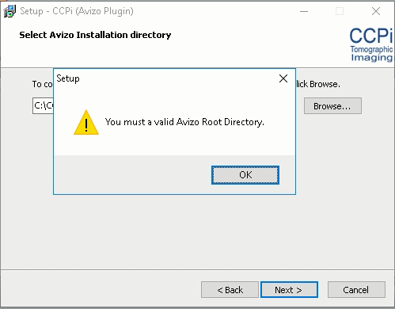

1. Avizo

[all-in-one plugin] Don’t separate reconstruction, quantification, etc. Just one – CCPi core plugin.

[CCPi Avizo Pluginv0.7.7.exe](https://ccpforge.cse.rl.ac.uk/gf/download/frsrelease/373/8249/CCPi%20Avizo%20Pluginv0.7.7.exe), Avizo 9.2

Why only has five algorithms?

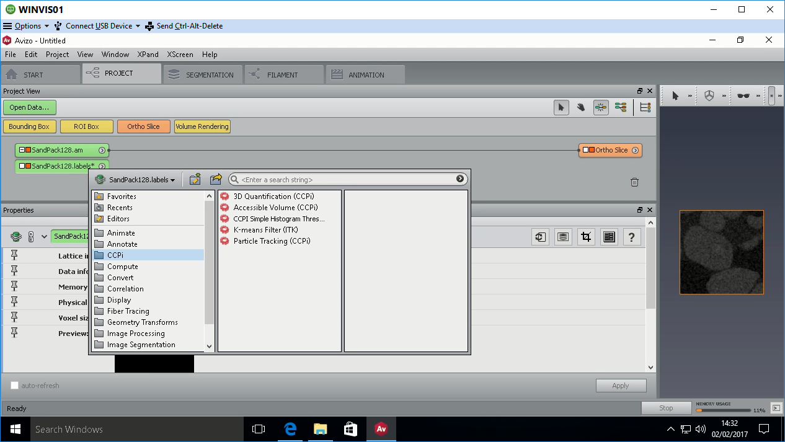

## Documentation

1. Add a section on how to add a new algorithm to the core CCPi toolbox – developer guide
   1. Development environment
   2. Library dependency
   3. Compilation environment
   4. Integration guide
      1. How to integrate the new code with Avizo
      2. How to integrate the new code with Paraview
      3. How to integrate the new code with ImageJ
2. Add a section on architecture of CCPi toolbox
3. How to compile CCPi Toolbox into a standalone library
4. Add a main program to the core toolbox to give a command line option
5. Add description of algorithms for
   1. 3D quantification
   2. Particle tracking
   3. Accessible volume
   4. Simple threshold

CCPi Quantification Algorithms & Toolbox

|  |  |  |  |
| --- | --- | --- | --- |
| **Algorithm** | **Source** | **CCPi contact** | **When** |
| Accessible Volume | Sheng Yue PhD thesis. (<http://dx.doi.org/10.1016/j.jmatprotec.2014.05.006>) | Peter Lee/Manchester | 2014 |
| 3D Quantification | Yue S, Lee PD, Poologasundarampillai G, Jones JR. DOI: [10.1016/j.actbio.2011.02.009](https://dx.doi.org/10.1016/j.actbio.2011.02.009) | Peter Lee/Manchester | 2009 |
| Particle Tracking | Originally developed by Peter Lee | Peter Lee/Manchester | ?? |
|  |  |  |  |